TECHNICAL PROJECT REPORT

# Title of Invention / Project:

**Indicator Module for Cyclist**

# Team Members / Inventors:

|  |  |  |  |  |  |
| --- | --- | --- | --- | --- | --- |
| **S. No.** | **Name** | **Department** | **Designation** | **Mobile** | **E-Mail** |
| 1. | Hrithik Johri | CSE | Student | 9027383079 | [hrithikjohri@gmail.com](mailto:hrithikjohri@gmail.com) |
| 2. | Kshitij Murabatte | CSE | Student | 7984912942 | [kshitijmurabatte@gmail.com](mailto:kshitijmurabatte@gmail.com) |
| 3. | Chirag Sabharawal | CSE | Student | 9991788440 | chiragsabharwal2099@gmail.com |
| 4. | Anand Mohan | CSE | Student | 7021147699 | Kanandmohan8@gmail.com |
| 5. | Khushal Thakur | ECE | Mentor | 9646030764 | [khushal.thakur@cumail.in](mailto:khushal.thakur@cumail.in) |
| 6. | Anshul Sharma | ECE | Mentor | 9478697475 | [anshulsharma.ece@cumail.in](mailto:anshulsharma.ece@cumail.in) |
| 7. | Kiran Jot Singh | ECE | Mentor | 9463909689 | [kiranjotsingh.ece@cumal.in](mailto:kiranjotsingh.ece@cumal.in) |
| 8. | Divneet Singh Kapoor | ECE | Mentor | 9878422653 | [divneet.ece@cumail.in](mailto:divneet.ece@cumail.in) |

Section – 1 (IPR Related)

# Brief Abstract (500 words):

The main idea of the project is to create riding modules for cyclist which would help them on the road. Cyclist are least given attention to on the roads. Some cyclist like to ride in early morning or at night after having dinner for exercising or as a hobby. But they are sometimes not seen by vehicles passing from there. So to help them to be visible and give other vehicle drivers better understandability of the cyclist’s movements we have made a Indicator Module for cyclist.

It helps as while turning the indicators on the module help the vehicle drivers behind to identify the cyclist. It has a huge white coloured LEDs in the middle which is always ON and highlights the cyclist while on the road. As it’s a module it can be installed on any preferred outfit. The indicator system has a let and a right arrow which start making a wave pattern as soon as cyclist tries to make a turn. We has also added a on/off switch which helps the user to conserve the battery life of batteries and be needing less maintenance.

The module is completely safe from electrical shocks and is completely insulated. Additionally no power components of circuit are tangible by the user on a daily basis. Even though if he/she touches the wires it would be completely harmless as the batteries only supply a voltage of 9V. The circuit has been divided into two parts the arrow segment and the always on white LED part. These two are completely independent of each other even in matters of power supply, so one won’t stop the other anytime.

We have tried to keep connecting wires at their minimum and also kept the accessibility in our minds. The product is flexibly and can be easily wore on the back of the cloth one’s wearing. Due to it’s flexibility it can withstand stretches and compresses suffered rough rides on bad roads the module is well attached to the cloth so it doesn’t fallout simply.

The basic idea of project was to provide cyclists with protection on roads while turnings on turns and be more visible to other vehicles on the road. The while LED part can also be used a screen to display a huge variety of thing like logos, patterns, etc.

# Existing state-of-the-art and Drawbacks in existing state-of-the-art

(*Brief background of the existing knowledge*)

|  |  |  |
| --- | --- | --- |
| **S. No.** | **Existing state of art** | **Drawbacks in existing state of art** |
| 1 | Indicator module  (DE10106291A1) | Used mercury containing tilt switchers that could be harmful when in contact with skin. |
| 2 | Radium Highlighter | Only highlights when light falls on it, useless in daylight. |
| 3 | Directional indicator  (GB2440552A) | Complex circuit not possible to mimic for a normal person and includes small parts difficult to handle and solder. |

.

# Novel/Additional modifications that you can propose to improve upon drawbacks

* *A mega Arduino can be used to have a better programmability for the white LED display through which one can display quite a variety of stuff.*
* *A buzzers similar to ones in bikes which buzzes while indicator is on can be used for the module adding even more attention to cyclists.*
* *A proximity sensor to adjust the intensity of light proportionate to the light in the surround to offer maximum battery optimisation and visibility.*
* *Adding a Bluetooth controlled switcher than could be controlled a smartphone connected with module via Bluetooth.*

# Advantages

* *The module is user friendly and allows cyclist to be safe while riding at night and low visibility places. The module increases visibility of rider and also allows the user to follow the traffic rules.*
* *It is completely safe from any electrical shocks and is very handy when is comes to safe cycling.*
* *Has a controller for controlling the while LED portion in the module.*
* *As it a module it can attached on any piece of clothing.*
* *It can help the cyclists and prevent a lot of accidents caused on day to day basis saving lives and making the road traffic security better and better with every passing day.*
* *Increases visibility during cloudy and foggy weathers and keeps the rider safe.*

Section – 2 (Real Project)

# Materials

|  |  |  |  |  |
| --- | --- | --- | --- | --- |
| Sr No. | Material Name | Remarks | Quantity | Price(in Rupees) |
| 1) | Accelerometer | - | 1 | 270 |
| 2) | Arduino | A uno would be useful | 1 | 530 |
| 3) | Connecting Wires | Try to different colour wires | As per need | 5/metre |
| 4) | Red LED strip | Make sure it can be cut | 1 metre | 35/metre |
| 5) | White LED strip | Make sure it can be cut | 5 meter | ~150 |
| 6) | Batteries | 9V ones will do | 3 | 30 |
| 7) | Arduino cable | - | 1 | 180 |
| 8) | Jumper Wires | Male to Female | As per need | 4/piece |
| 9) | Switch | - | 1 | 10 |
| Total : 1255 |

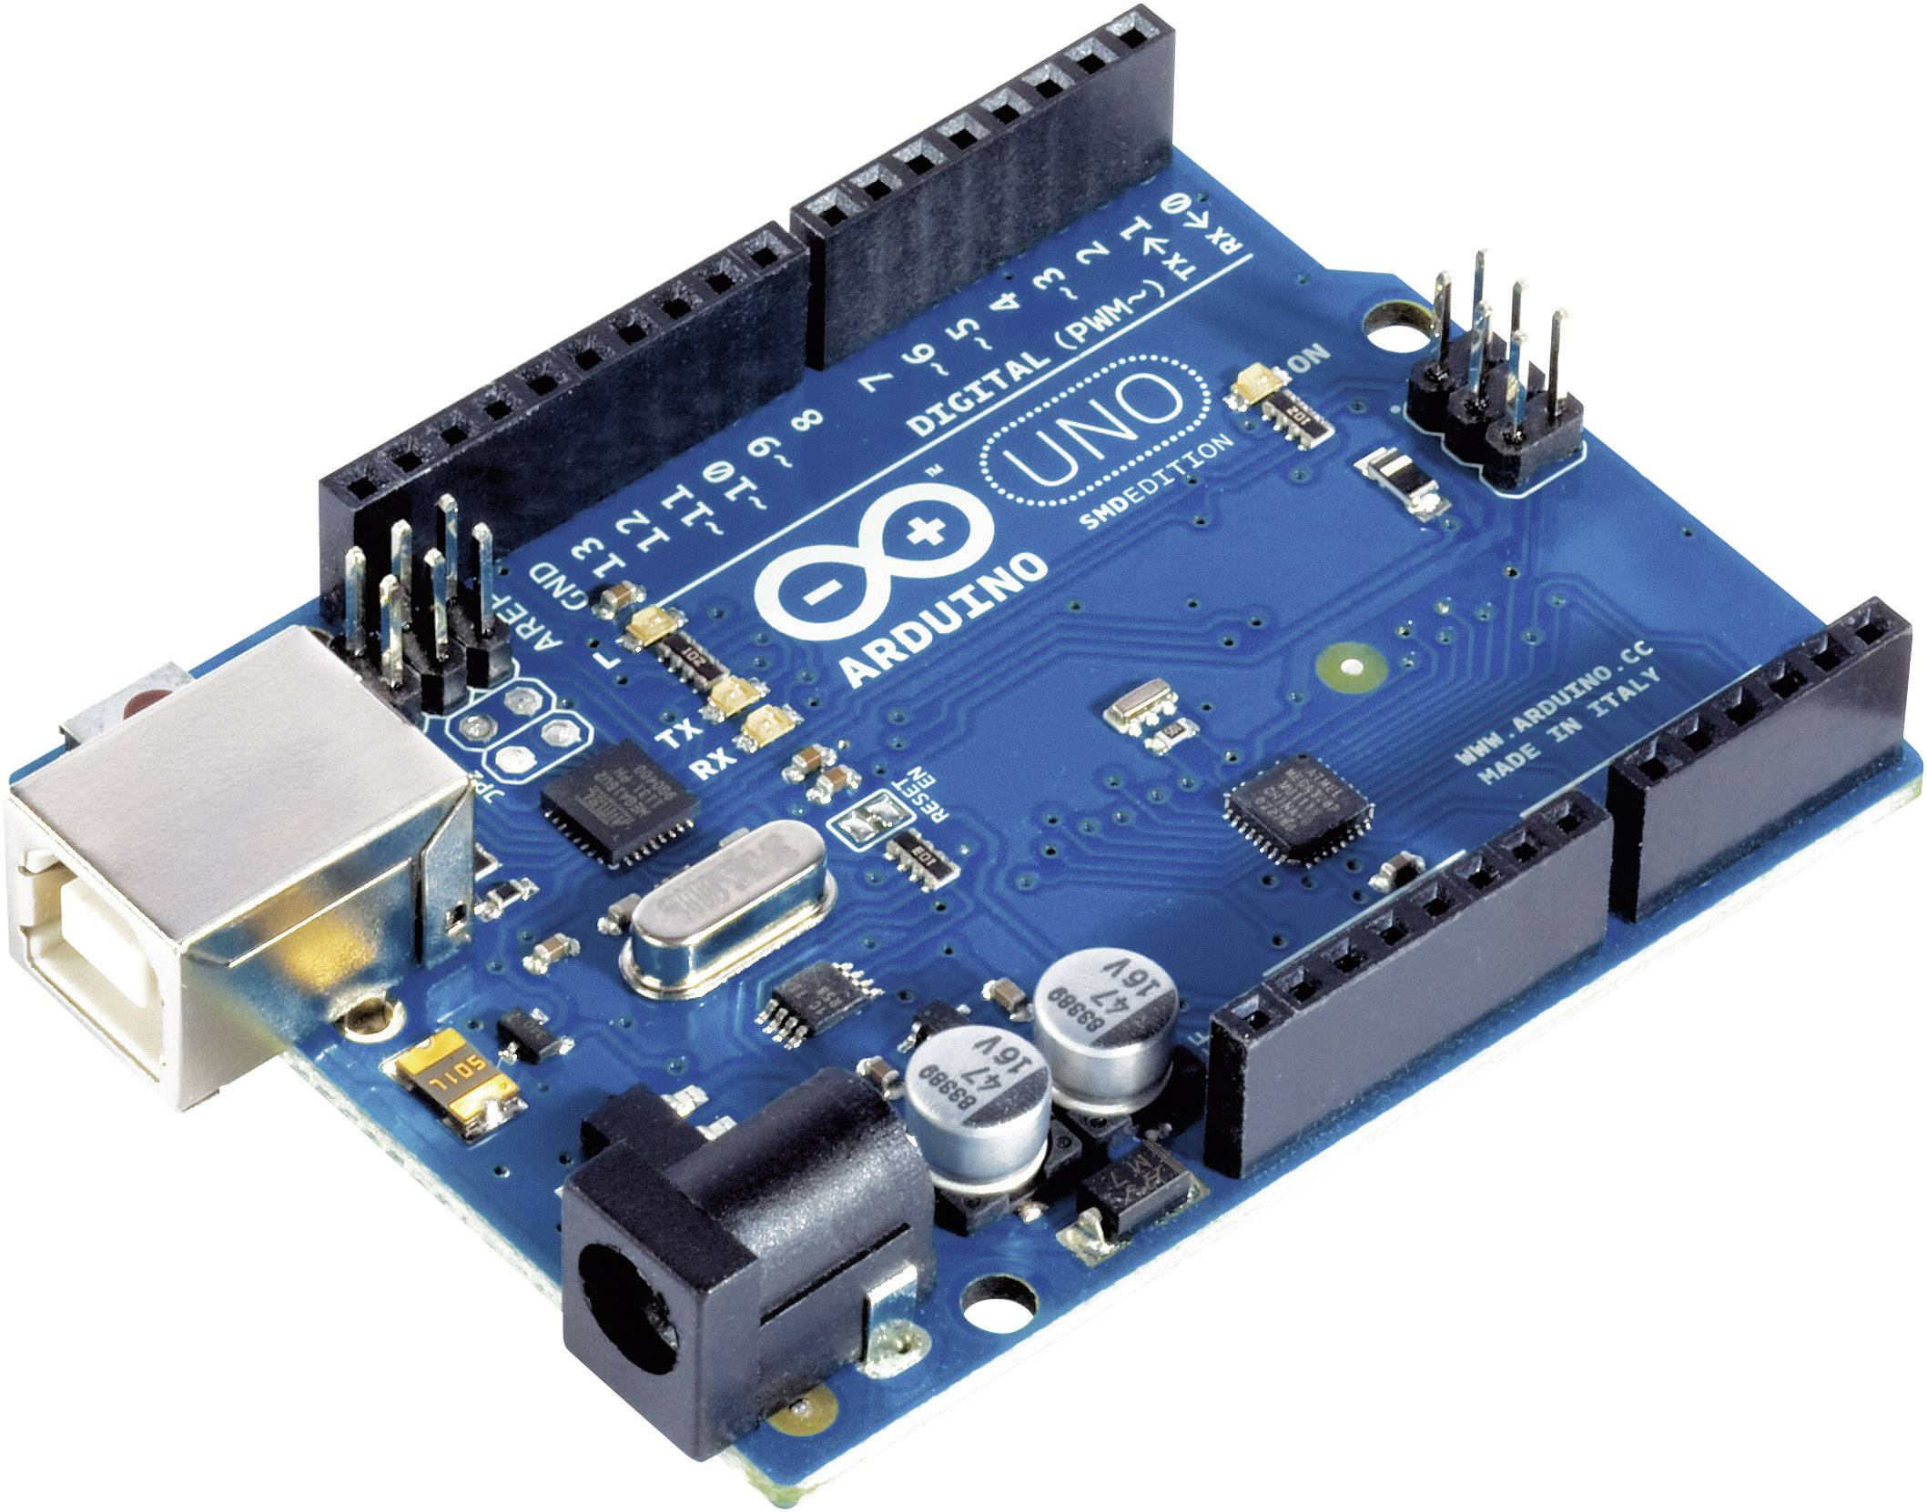 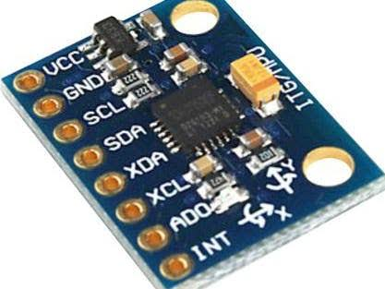 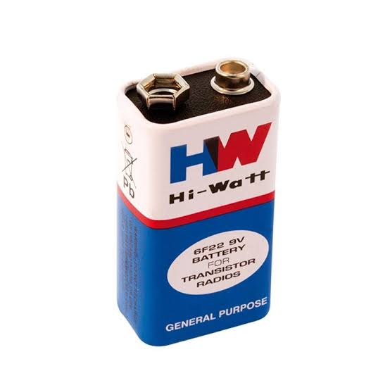

Arduino (UNO) Accelerometer 9V DC Battery

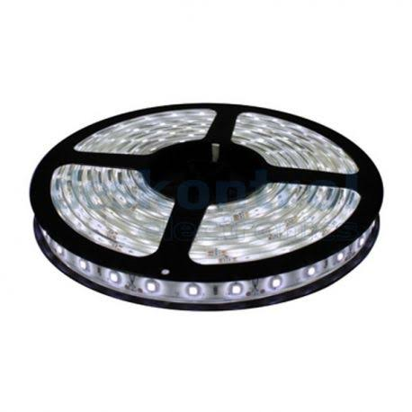 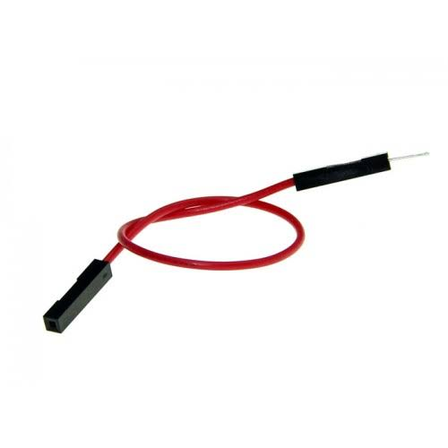 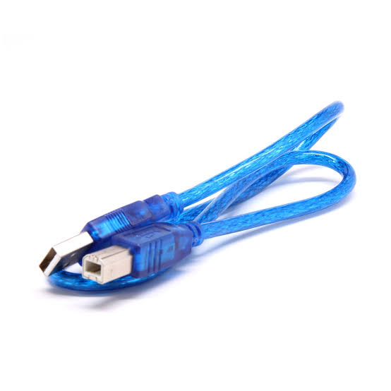

LED Strip Jumper Wire Arduino Cable

# Steps of Circuit Completion

1) Collecting all the required materials for the project.

2) Making a basic idea for the circuiting and where and how to place components keeping in sight the comfort of the who wears as well as making the module less complicated.

3) Coil the while LED strip over a piece of cardboard.

4) Take the red LED strip and try to find the cut marks highlighted over it and cut it counting 3 LEDs , then make another three. Now do same while counting 6 and 9 LEDs four times.

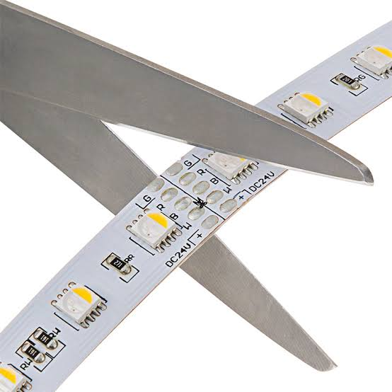

5) Take the recently cut segments then connect the two 9 LED segment with each other in series positive with positive and negative with negative and do the same with the 6 and 3 LED segments.

6) Now you should stick them together to make left and right arrows the ones to be used as turning as indicators.

7) Assemble the circuit on a flexible board keeping while LED board in middle while left and right arrows on their respective positions.

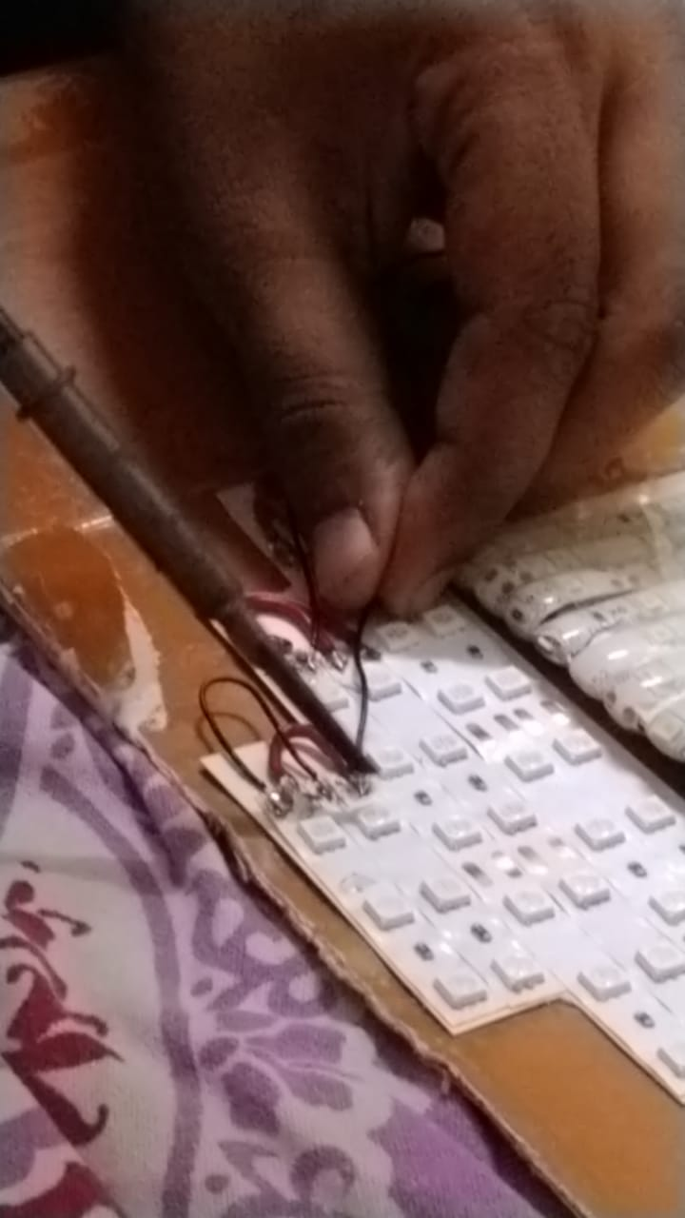

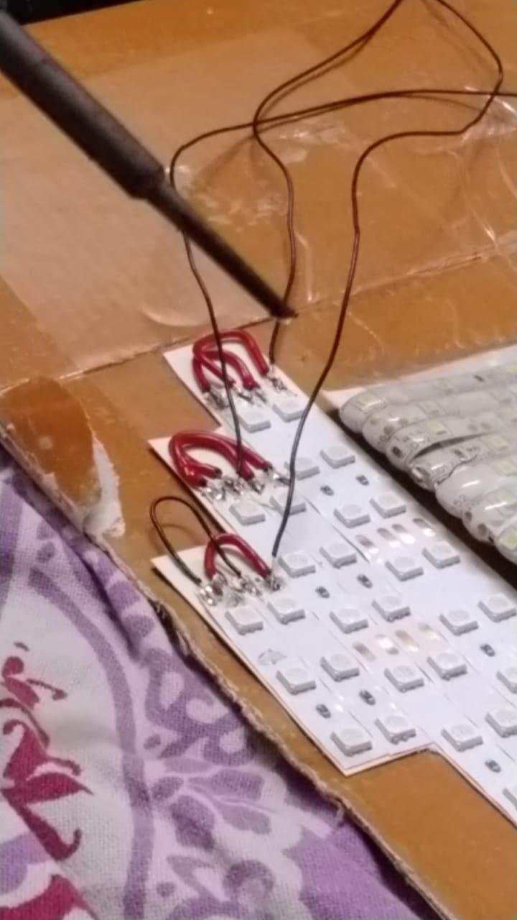

# Program Code

#include<Wire.h>

// ADXL345 I2C address is 0x53(83)

#define Addr 0x53

void setup()

{

// Initialise I2C communication as MASTER

Wire.begin();

// Initialise serial communication, set baud rate = 9600

Serial.begin(9600);

// Start I2C Transmission

Wire.beginTransmission(Addr);

// Select bandwidth rate register

Wire.write(0x2C);

// Normal mode, Output data rate = 100 Hz

Wire.write(0x0A);

// Stop I2C transmission

Wire.endTransmission();

// Start I2C Transmission

Wire.beginTransmission(Addr);

// Select power control register

Wire.write(0x2D);

// Auto-sleep disable

Wire.write(0x08);

// Stop I2C transmission

Wire.endTransmission();

// Start I2C Transmission

Wire.beginTransmission(Addr);

// Select data format register

Wire.write(0x31);

// Self test disabled, 4-wire interface, Full resolution, Range = +/-2g

Wire.write(0x08);

// Stop I2C transmission

Wire.endTransmission();

delay(300);

// LED strip to left

pinMode(1,OUTPUT);

pinMode(2,OUTPUT);

pinMode(3,OUTPUT);

//LED strip to right

//pinMode(9,OUTPUT);

//pinMode(10,OUTPUT);

//pinMode(11,OUTPUT);

}

void loop()

{ //the center is always going to be on

//digitalWrite(5,HIGH);

unsigned int data[6];

for(int i = 0; i < 6; i++)

{

// Start I2C Transmission

Wire.beginTransmission(Addr);

// Select data register

Wire.write((50 + i));

// Stop I2C transmission

Wire.endTransmission();

// Request 1 byte of data

Wire.requestFrom(Addr, 1);

// Read 6 bytes of data

// xAccl lsb, xAccl msb, yAccl lsb, yAccl msb, zAccl lsb, zAccl msb

if(Wire.available() == 1)

{

data[i] = Wire.read();

}

}

// Convert the data to 10-bits

int xAccl = (((data[1] & 0x03) * 256) + data[0]);

if(xAccl > 511)

{

xAccl -= 1024;

}

int yAccl = (((data[3] & 0x03) * 256) + data[2]);

if(yAccl > 511)

{

yAccl -= 1024;

}

int zAccl = (((data[5] & 0x03) * 256) + data[4]);

if(zAccl > 511)

{

zAccl -= 1024;

}

// Output data to serial monitor

Serial.print("Acceleration in X-Axis is : ");

Serial.println(xAccl);

Serial.print("Acceleration in Y-Axis is : ");

Serial.println(yAccl);

Serial.print("Acceleration in Z-Axis is : ");

Serial.println(zAccl);

if(xAccl>0)

{ //Indecation for left side

digitalWrite(1,HIGH);

delay(500);

digitalWrite(2,HIGH);

delay(500);

digitalWrite(3,HIGH);

}

else

{ //indication for right side

digitalWrite(9,HIGH);

delay(500);

digitalWrite(10,HIGH);

delay(500);

digitalWrite(11,HIGH);

}

delay(300);

}

